Sanitation and Hygiene

Handwashing- a 20 second process:
- The handwashing sink is to be used for ______________________ ONLY.
- ____________________ hands and arms with warm/hot water.
- Apply ____________________________.
- _________________ hands and arms vigorously for at least _______________ seconds.
- ________________________ hands and arms thoroughly.
- Use an antiseptic __________________ washing hands
  - Wait for antiseptic to dry before touching food or equipment and before putting on gloves.
- Dry hands and arms with a _______________________________.
- Do not use apron or clothing.
- Use paper towels to ______________________ the faucet and _____________ doors.
When to Wash Hands:
- After using the __________________
- After coughing/sneezing
- Before & after handling raw meat, poultry or eggs
- ________________ putting on gloves
- After touching clothing or aprons
- After handling money
- __________________ handling garbage or trash
- After handling dirty equipment/utensils
- ________________________________________ food preparation

Clothing, Hair and Jewelry:
- Wear _______________ clothing and aprons.
- _________________________ or cover hair.
- Remove jewelry from hands and arms including rings, bracelets and watches.
  - Expect for a __________________________

Wearing Gloves:
- ___________________________ bare-hand contact with ready to eat foods.
- Wear gloves if you have ________________________________ on hands.
  - A bandage must cover the wound completely and a glove must be worn over the bandage.
- Use the correct size so they fit.
- Never rinse, wash or ____________________ gloves.
- Wash hands before putting on gloves and when changing to a new pair.
- Change gloves with each _________________________.

Cleaning and Sanitizing
- Keep all work surfaces ________________.
- Disinfect work surfaces to prevent cross-contamination.
- Surfaces that are in constant use must be cleaned and sanitized after _______________.
- Clean crumbs and spills, store staples in airtight containers and dispose of garbage properly to reduce pests/insects.
- If taste testing foods, always use a ___________________ and use it only ___________.
- Store towels for cleaning food spills in __________________ solution when you are not using them. Never store them in your apron or uniform pocket.
- Always use cleaners and sanitizers according to the ________________________.
- Sanitizer must be left on the surface for the correct amount of time to _________________ pathogens on surface to a safe level.
- Use a ____________________ to check the sanitizers strength to ensure it is effective.
To Sanitize:
- ______________ the surface.
- Rinse the surface.
- _________________ the surface.
- Allow the surface to ________________ dry.
Wash dishes in the following order- BY HAND:  - Rinse and _________________ Food  - Glassware  - _____________________  - Dishware (Plates/Bowls)  - Kitchen Tools  - ___________________________ | Dish Washing- DISH MACHINE  - Dish machines are used in the __________ to quickly clean and sanitize dishes.  - Scrape, rinse or soak items before washing.  - Never _________________ the dish racks and use the correct racks.  - Frequently check water temperature and pressure.  - Change the ___________ when necessary.
Dish Washing- 3 SINK METHOD:
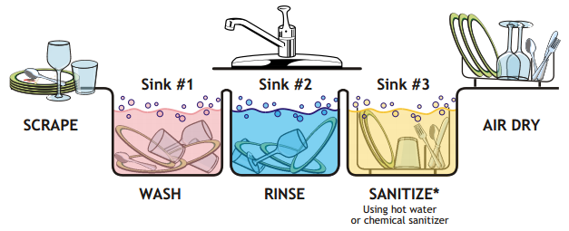
Storing Dishes and Utensils  - _______________________ in a clean, dry location.  - Store at least __________________________________ the floor.  - Store upside down on a clean, sanitized surface.  - If storing utensils vertically, store them with _____________________________ | Trash and Garbage  - Remove garbage from ______________________ area as quickly as possible.  - Do not clean garbage containers need food prep areas.  - Use trashcan _________________________  - Clean the inside and outside of garbage containers often.________________________ the lids on outdoor containers.

